INSTRUCTIONS ON HOW TO ACCESS FEES ONLINE

Go to www.eips.ca
Click on Powerschool Parent Portal
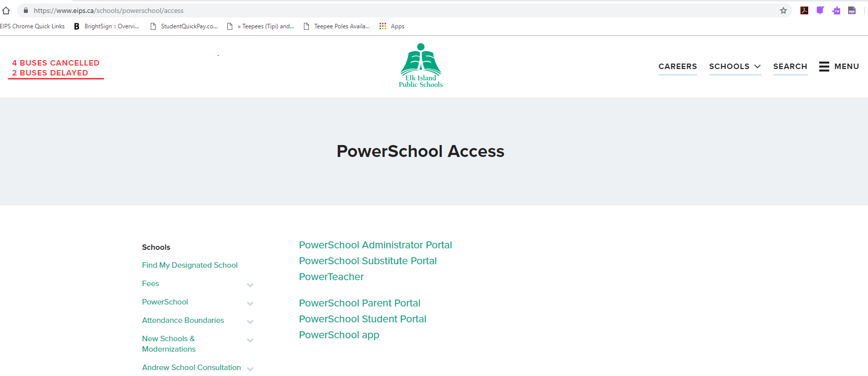

Login in to your account. If you do not already have a log in, click on “Create Account”. If you need assistance with access codes, please contact the school office.
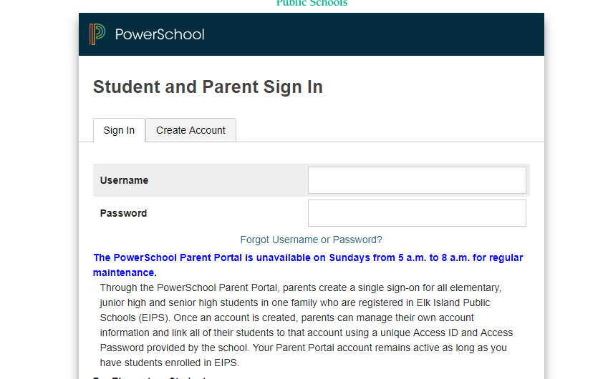

Click on the “Student Fees” option
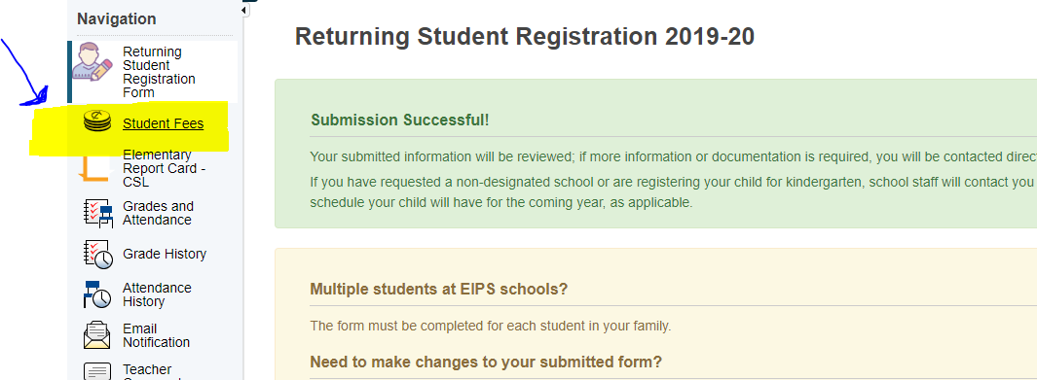

It will then bring you to this screen. If there are fees outstanding they will appear in the cart in the upper right hand side. Click on that cart to checkout and pay.
